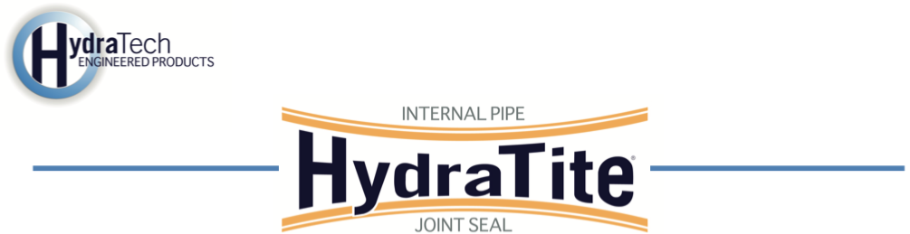
Market
Stormwater/DOT

Challenge
An inspection by the Minnesota Department of Transportation (MnDOT) identified joint deterioration and infiltration risks within an 88" x 54" stormwater culvert (pipe arch) running beneath a major roadway. Traditional repair methods, such as excavation or full pipe replacement, would have required road closures and caused significant disruption to traffic. MnDOT sought a trenchless rehabilitation solution that could restore joint integrity without disturbing the traveling public.

Engineered Solution
HydraTech manufactured custom HydraTite® Internal Pipe Joint Seals, a mechanical trenchless repair method designed to permanently stop infiltration at pipe joints. The project required double-wide HydraTite® seals, each equipped with three stainless-steel retaining bands. Each of these bands were constructed from 4 pieces.

Scope
Prior to HydraTech’s arrival, the pipe was prepped and cleared, ensuring the joints were ready for immediate installation. A three-person HydraTech field crew mobilized to the site and installed nine HydraTite® double-wide. Despite the confined conditions and unique pipe geometry, all nine seals were successfully installed in just two days.

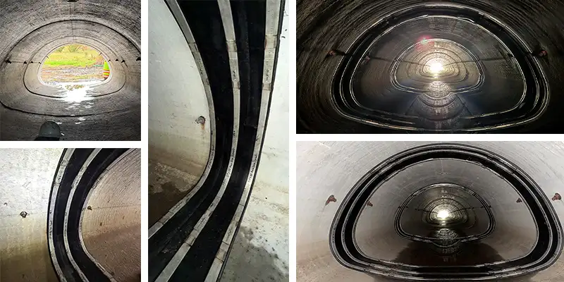

Solution
The completed installation effectively sealed all nine joints, preventing groundwater infiltration and extending the service life of the large stormwater culvert. The HydraTite® system provided MnDOT with a cost-effective, long-lasting repair that eliminated the need for excavation or traffic disruption. This project demonstrated how trenchless internal joint sealing can repair critical transportation infrastructure while keeping the public moving safely overhead.

HydraTech Engineered Products, LLC
HydraTech Field Services, LLC
10448 Chester Road, Cincinnati, Ohio 45215 Phone: (513) 827-9169 Fax: (513) 827-9171
http://www.hydratechllc.com
https://www.hydratechfs.com

