
Market
Drinking Water

Challenge
During the installation of a 20” diameter cement-lined ductile iron pipe, a gasket was rolled, resulting in a leak. This pipe installation was part of a larger drinking water tank construction project in Iowa. Replacing the new pipe, which had only one compromised point, would disrupt the rest of the project, costing time and money. This motivated the project owners to investigate an internal repair.

Engineered Solution
The project owners elected to use a single standard-wide HydraTite Internal Pipe Joint Seal with a test valve and a pair of two-piece retaining bands to eliminate the leak.

Scope
Two HydraTech technicians installed the seal in one day. A technician was lowered to the compromised gasket, about 8 feet into the pipe. Once inside, the concrete liner was chipped away, and the rubber seal was positioned over the joint. The retaining bands were loosely installed over the rubber and the expander head was positioned in the expansion point in the first retaining band. Due to movement being limited in the pipe, the expander’s pump was operated by the second technician outside the pipe. Together they expanded each retaining band and the technician inside the pipe locked the bands in place with wedges. The seal then passed an air test using the valve in HydraTite’s rubber. After HydraTech’s technician vacated the pipe, a sustained hydrostatic pressure test was run for two hours. HydraTite passed this test as well.

Solution
A simple installation mistake could have resulted in replacing new pipe and disrupting the rest of this construction project, but thanks to HydraTite, the joint was fortified against leaks and the project started back up quickly. HydraTite proved to be a cost-effective and time-saving repair.

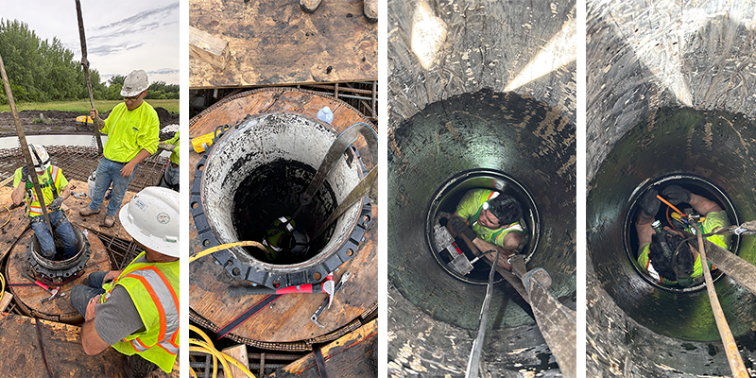

DISCLAIMER
The minimum diameter for the HydraTite seal is generally 24”, but unique circumstances may allow for smaller diameter seals.

HydraTech Engineered Products, LLC
HydraTech Field Services, LLC
10448 Chester Road, Cincinnati, Ohio 45215 Phone: (513) 827-9169 Fax: (513) 827-9171
http://www.hydratechllc.com
https://www.hydratechfs.com

