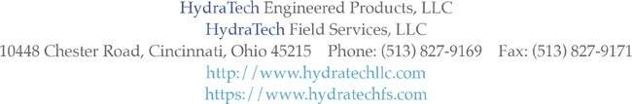
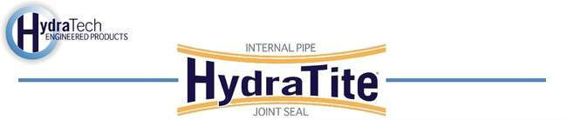
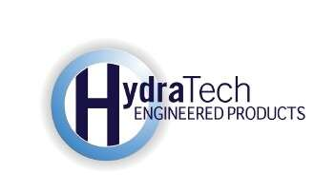

https://hydratechllc.com https://hydratechllc.com/services/field-services/

Market
Water & Utilities

Challenge
A 66” corrugated metal pipe utilized as a dam overflow had developed a hole, which allowed
water infiltration.

Engineered Solution
The overflow pipe was buried under several feet of gravel and had a concrete pad above it. This
eliminated excavation as an option. The engineer reviewed other trenchless repair techniques such as grout or plugs to perform a point repair inside the pipe. After reviewing several options the engineer selected the HydraTite Internal joint seal as a long-term, economical repair. The double-wide seal was selected to cover the area and four retaining bands were used to permanently seal the leak.

Scope
The surface of the pipe was prepared by filling in the valley of the corrugated metal to provide a
smooth surface for the seal to be installed. HydraTite was then placed over the repair location and two retaining bands were installed in the rubber’s channels. Then the seal was air tested. Finally, the two additional bands were installed. The entire repair was completed in just one day.

Solution
The HydraTite Internal Pipe Joint Seal proved an economical and practical way to stop infiltration
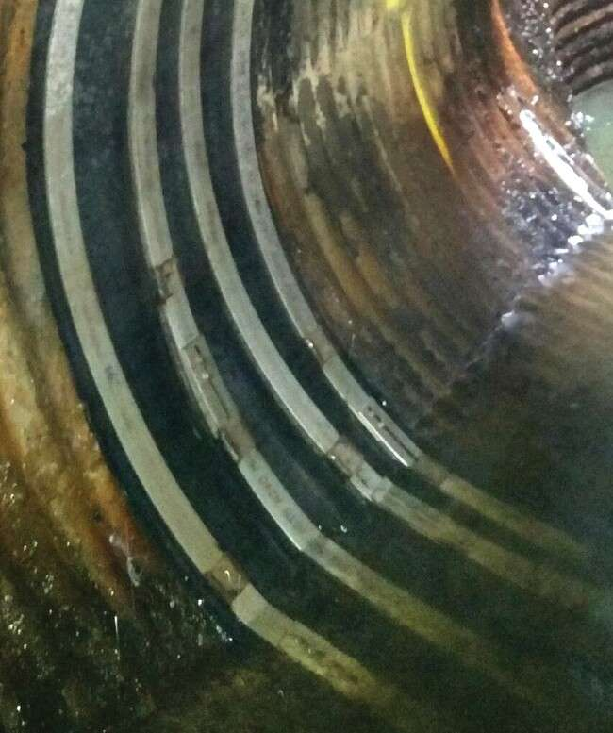
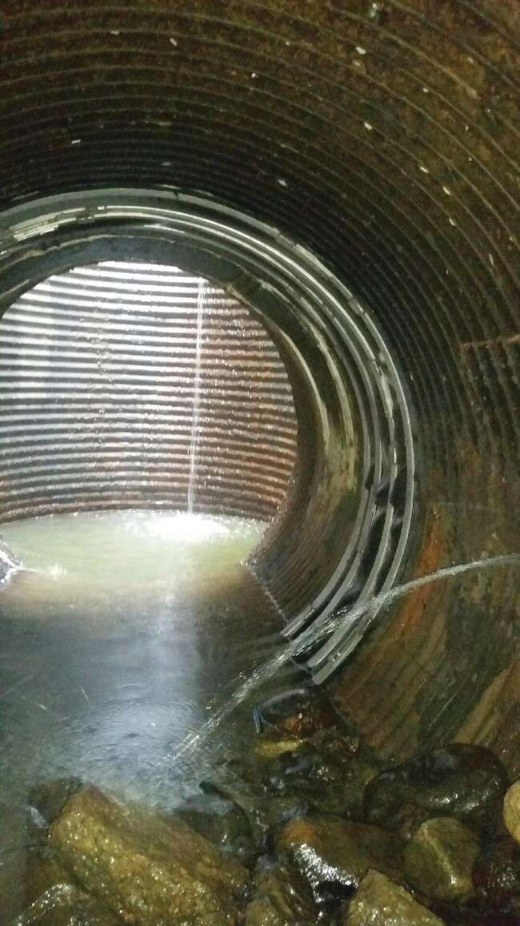
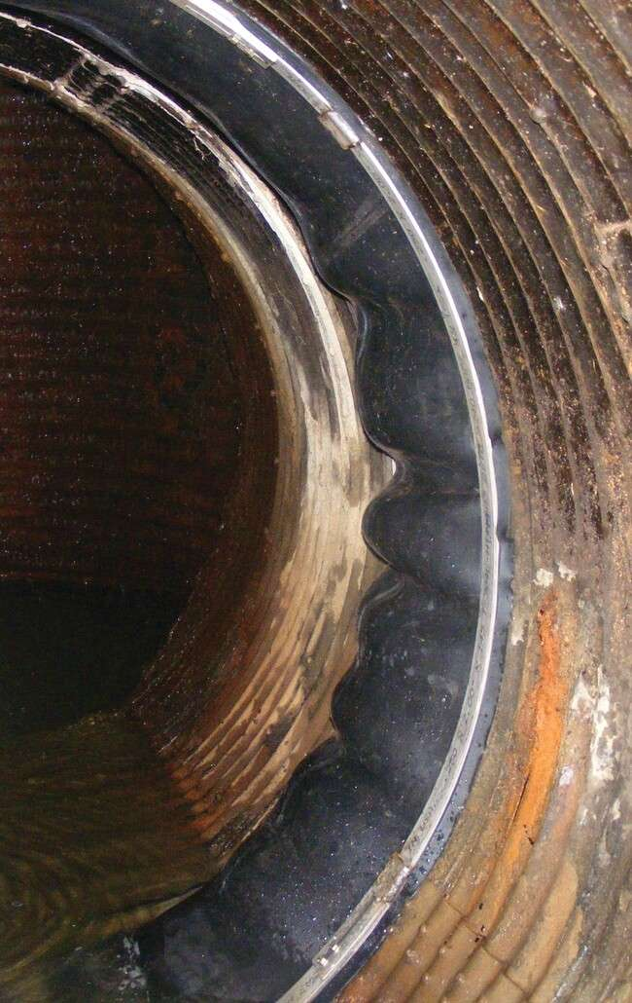
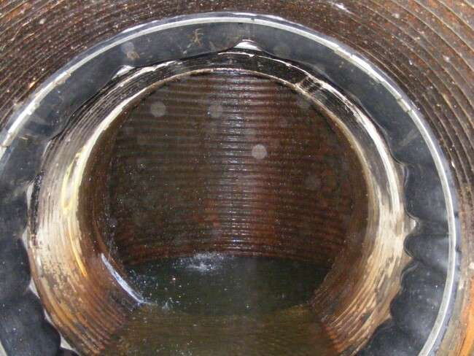
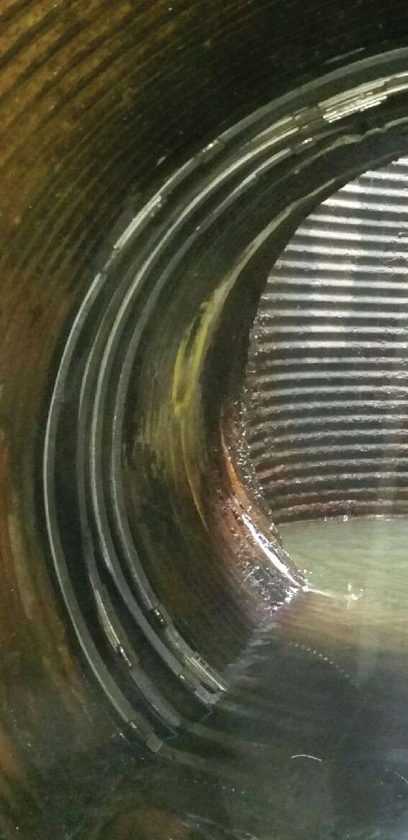
through the hole in the corrugated pipe. This repair brought new life to the corrugated pipe that would have otherwise required replacement.

