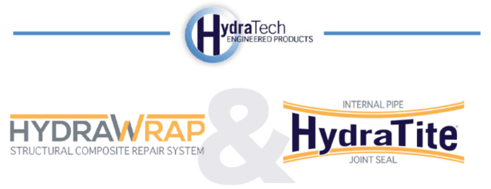

Market:
Power Generation
Challenge:
The challenge was to repair cooling water piping corrosion.
Engineered Solution:
The solution utilized the HydraWrap® Structural Composite Repair System, as well as the HydraTite® Internal Joint Sealing System.
Scope:
The cooling water pipe system consisted of approximately 1,500 feet of 72-in carbon steel piping. The system supplied cooling water to vital components in the power plant. Inspections conducted on the cooling water pipe revealed signs of corrosion with a significant amount of wall loss in certain areas. Rehabilitation was required to prevent further corrosion and add structural reinforcement to the host pipe.
Solution:
The client specified a carbon fiber composite system and selected HydraWrap® for its corrosion resistant and structural properties, coupled with its economical pricing. The terminations of the HydraWrap® carbon fiber lining were sealed with HydraTech’s HydraTite® internal pipe seals. The installation involved proper surface preparation by high pressure water and abrasive blasting. The project was successfully completed during the scheduled outage at a fraction of the time and cost it would have taken for direct replacement.
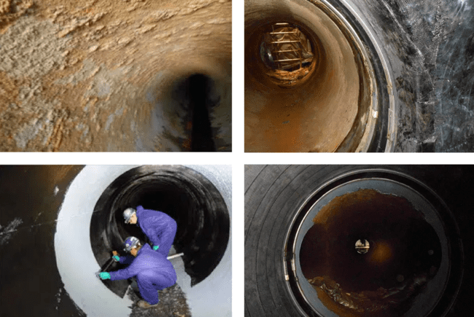

HydraTech Engineered Products, LLC
HydraTech Field Services, LLC
10448 Chester Road, Cincinnati, Ohio 45215 Phone: (513) 827-9169 Fax: (513) 827-9171 http://www.hydratechllc.com
https://www.hydratechfs.com

