

Market
Municipal

Challenge
An aging water line in Louisiana raised the concern of eventually losing pressure. A preventative solution was needed to prevent the joints from becoming compromised in this 48” pipeline.

Engineered Solution
Standard-wide HydraTite Internal Pipe Joint Seals were ordered to extend the water line’s service life.

Scope
Tuberculation had formed in the pipe and this buildup had to be scrapped off of the interior surface of the pipe near the joints. Once the tuberculation was cleaned up the rubber seals were put in place and the retaining bands were used to lock the rubber in position over the joint. Finally, the seals were air tested to ensure that the installation was a success. 29 seals were installed in 4 days.

Solution
HydraTite extended the service life of this waterline by eliminating leaks. This installation will outlast grout for many years.

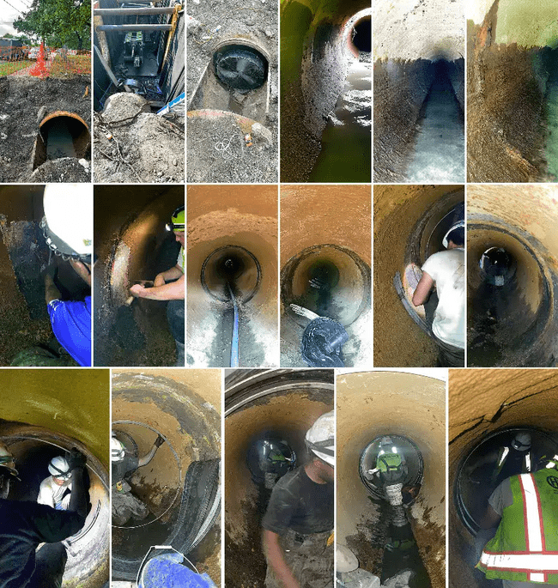

HydraTech Engineered Products, LLC
HydraTech Field Services, LLC
10448 Chester Road, Cincinnati, Ohio 45215 Phone: (513) 827-9169 Fax: (513) 827-9169
https://hydratechllc.com
https://hydratechllc.com/services/field-services/

