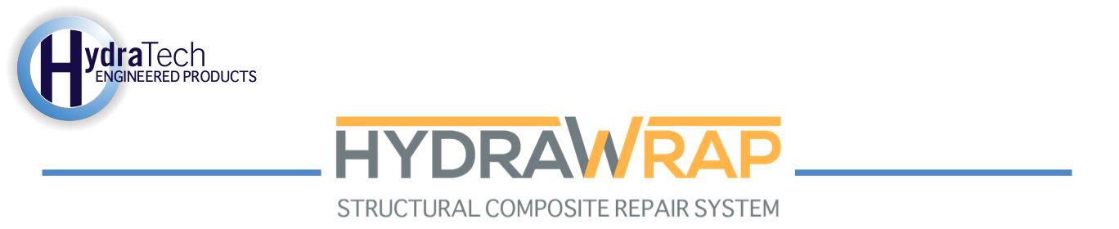

Market:
Sanitation
Challenge:
A county’s sanitation department discovered that a 12” steel pipe was leaking in their wastewater wet well. The leak was 1” away from where the pipe met the wall. They needed to restore the pipe to return the system to proper operations.
Engineered Solution:
They chose to apply the HydraWrap Structural Composite Repair System. They were supplied with 6” wide fabric and acid-resistant epoxy.
Scope:
The leak was temporarily stopped and the surface of the pipe was prepared to achieve a mechanical profile. Primer was applied to the pipe’s surface. The carbon fiber fabric was then saturated and the repair area was covered with two layers.
Solution:
HydraWrap proved to be a simple solution that the client was able to apply quickly and allowed the pipe to be put back in service quickly. The entire project was completed at a fraction of the cost of replacement.

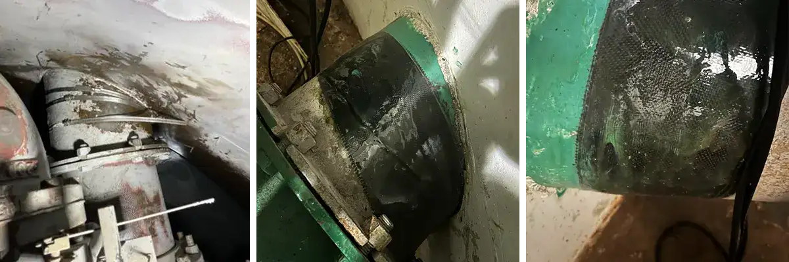

HydraTech Engineered Products, LLC
10448 Chester Road, Cincinnati, Ohio 45215
Phone: (513) 827-9169 Fax: (513) 827-9171
http://www.hydratechllc.com

