

Market
Private

Challenge
During the Cold War, a secret program saw the creation of a bunker under the Greenbrier resort. US congress members intended to retreat to this bunker if the conflict ever became hot. This bunker had air supply lines to ensure its inhabitants would not become trapped in stale air. This bunker was decommissioned in 1992 and has since become a historic landmark with tours. During efforts to preserve this relic of the past, leaks were discovered in the air supply lines. An internal solution was vital to ensure that this historic facility would not be altered.

Engineered Solution
Extra-Wide HydraTite Seals with three retaining bands were chosen to eliminate the leaks without disturbing the rest of the facility.



Scope
A crew of three people installed more than 10 seals over joints that had become compromised. Since the pipe was only intended to transport air and the infiltration was limited, the pipe did not have any water flow. The joints required minimal surface prep such as removing some debris. The rubber’s ribs were then lubricated, the rubber positioned over the joint, the stainless steel bands were loosely constructed, and the first two bands were positioned in the rubber’s designated channels. These two retaining bands were then brought to pressure with a hydraulic expander. The final retaining band was then placed over the rubber, between the two previously installed bands. The final band was then brought to pressure. Finally, each seal was air tested by pumping air behind the rubber, spraying a soapy water solution around the rubber, and inspecting the rubber’s edge for the formation of bubbles. The seals were all installed and air tested in about a week.

Solution
This piece of history was not disturbed while the joints in the air supply lines were fortified against leaks. This repair method will guard these joints for a lifetime.

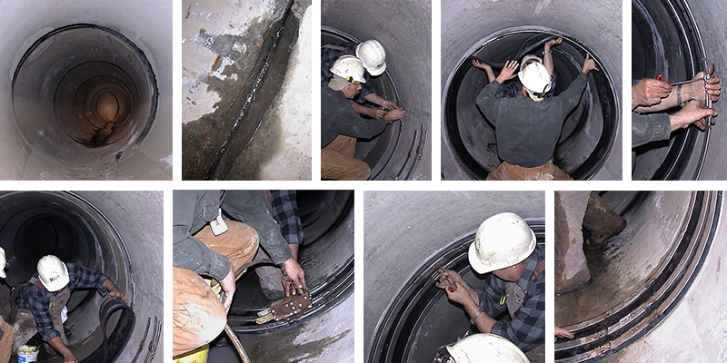

HydraTech Engineered Products, LLC
HydraTech Field Services, LLC
10448 Chester Road, Cincinnati, Ohio 45215 Phone: (513) 827-9169 Fax: (513) 827-9171 http://www.hydratechllc.com
https://hydratechllc.com/services/field-services/

