

Market:
Water & Utilities
Challenge:
Glass reinforced pipe (GRP) had previously been sliplined in a section of a 102” diameter prestressed concrete cylinder pipe (PCCP). A termination seal was desired to fortify this aqueduct’s transition from the 102” PCCP to the 90” GRP.
Engineered Solution:
Multiple HydraTite internal pipe joint seals were to be installed with grout in a unique repair engineered for this application.
Scope:
HydraTech provided a technician to instruct and oversee this installation. Several 2” by 5” EPDM spacers were first installed with a stainless steel retaining band locking them against the interior surface of the PCCP. Grout was then applied, creating a gradual gradient from the smaller diameter to the larger diameter. After the grout was cured, the retaining bands were removed. Next, three double-wide seals were installed in an interlocking fashion. The retaining bands were positioned so that the pressure was applied to the GRP, PCCP, or previously installed spacers now surrounded with grout.

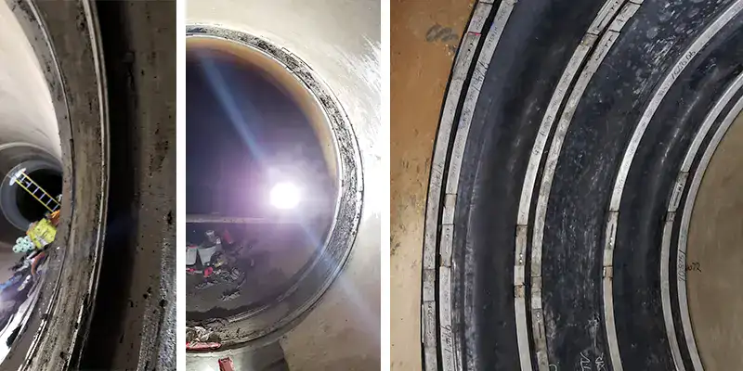
Solution:
The versatility of the HydraTite seal allowed for installation despite the different diameters between the GRP and PCCP. The transition is now fortified against the formation of leaks.

HydraTech Engineered Products, LLC
HydraTech Field Services, LLC
10448 Chester Road, Cincinnati, Ohio 45215 Phone: (513) 827-9169 Fax: (513) 827-9171 http://www.hydratechllc.com
https://hydratechllc.com/services/field-services/

