

Market:
Stormwater
Challenge:
During a visual inspection of 48" HDPE pipes in Massachusetts, multiple tears were discovered near the discharge to the catch basins. The tears were between eight to twelve inches in width. Excavation would be difficult due to the affected pipes being 25 feet below grade.
Engineered Solution:
To avoid excavation, HydraTite Internal Pipe Joint Seals were the selected repair method.
Scope:
Soil had fallen into the pipes and had to be removed before installation to ensure a proper seal. Then a backing plate was positioned over the first repair location. Two double-wide seals and one extra-wide seal were then installed in an interlocking fashion so that the outer ribs reached beyond the backing plate and pressed into the interior surface of the pipe. This process was repeated in the other two repair areas. Three sleeves, nine seals, were installed in two days.

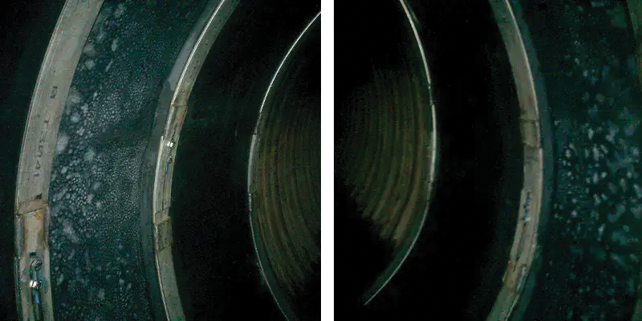
Solution:
HydraTite was installed quickly, providing a permanent repair that eliminated infiltration of groundwater and preserved the soil bedding around the pipes. The integrity of the pipes was restored without compromising the hydraulic capacity of the storm drain system.

HydraTech Engineered Products, LLC
HydraTech Field Services, LLC
10448 Chester Road, Cincinnati, Ohio 45215 Phone: (513) 827-9169 Fax: (513) 827-9171 http://www.hydratechllc.com
https://hydratechllc.com/services/field-services/

