

Market
Municipal

Challenge
Visible aging signs appeared in a large-diameter pipe that was part of a water lock. The concern of leaks drove the search for an internal solution for this 186-inch pipe.

Engineered Solution
It was decided that HydraTite Internal Pipe Joint Seals would be installed at the mortar-to-concrete transition.

Scope
First, HydraTech set up scaffolding. Then the field technicians began creating a smooth sealing surface for HydraTite by applying butyl rubber and concrete to the interior surface of the pipe. Next, the crew constructed the three retaining bands which came in 5 pieces each. The rubber was loosely positioned behind the retaining bands. Finally, the retaining bands were expanded and locked in place with wedges. The entire installation process took just over two days.

Solution
HydraTech quickly installed this seal and prolonged the service life of this pipe for a fraction of the time and cost associated with replacement.

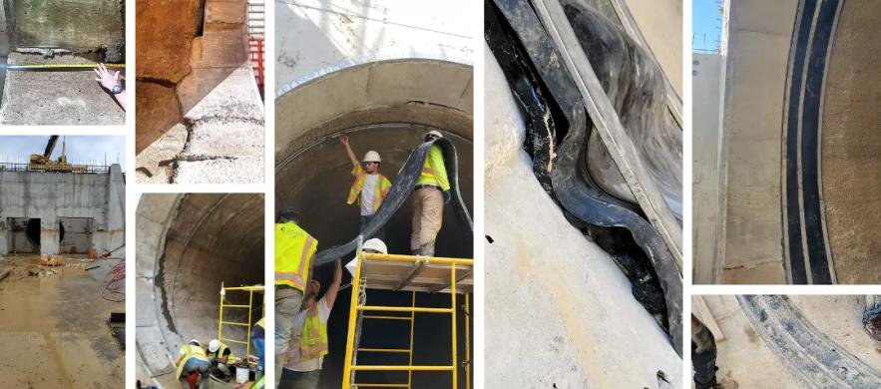

HydraTech Engineered Products, LLC
HydraTech Field Services, LLC
10448 Chester Road, Cincinnati, Ohio 45215 Phone: (513) 827-9169 Fax: (513) 827-9171
http://www.hydratechllc.com
https://www.hydratechfs.com

